IBM STC – New inbound Process with Upload PO

Date: 4th Sep 2008
David GH, Kenny Goh and Pei fong

Process flow:
- Upload Function (Admin)
  - IBM send PO file via email
  - Inbound Admin upload PO (New screen)
  - Create ASN (ITS) by input dummy IDDN# as “NA”
Assumption: 1 ASN = 1 Supplier and 1 PO
  - New Outstanding ASN Report (IDDN = NA) (New Report)

- Incoming detail Check (Operation)
  - Check detail no of pallets/carton, qty against documents
  - Record dimension, weight, COO. Paste Pallet ID
  - Record Location

- HUB- Inbound Process (Admin)
  - Inbound- selection by PO (changes)
  - Check PO, SKU and Qty
  - Confirm IDDN and change IDDN from NA to actual IDDN#
  - Enter dimension, weight, COO
  - RF receiving: scan LP, input qty and Location. (changes)
  - Print final Receipt Report - to include put-away location check. (changes)

- HUB – Import PO
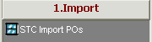

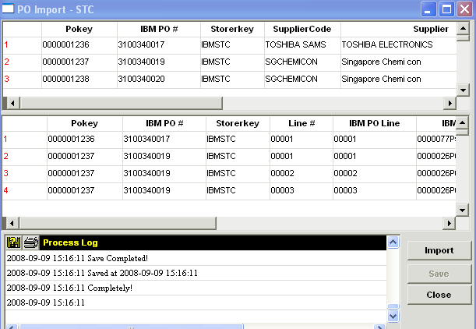

  - Click in button “Import” to select “GAP report” file. 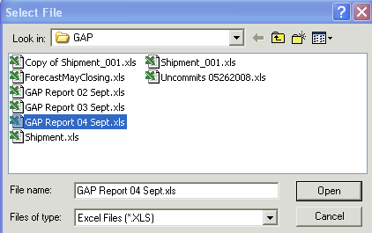
  - Then click “Open”
  - System will start processing the file.
  - Once completed, Process log will displayed “Save Completed!” Message.

- HUB – Create ASN by PO
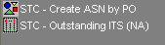
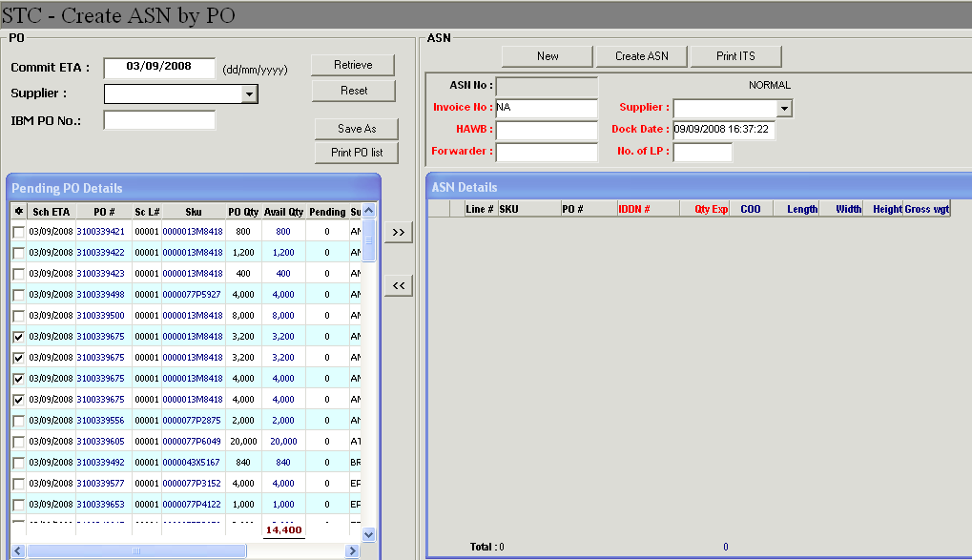

  - Retrieve Pending PO
- User can search by Commited ETA, Supplier or IBM PO No
- Click button [Retrieve] to retrieve pending PO List.

  - Check on the ‘Check box’ on the required PO detail to create ASN.
Assumption: 1 ASN = 1 PO

  - Click on button [New] to create temporary ASN
  - Click on button, system will auto-populate PO Detail to ASN Detail on the right.

  - Update ASN Header information:
Supplier: (must enter)
Forwarder (optional if available)
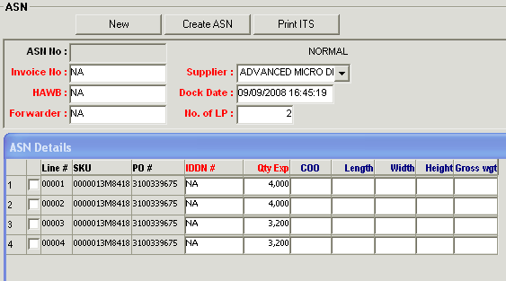

  - Click on button [Create ASN], to confirm and create the ASN.
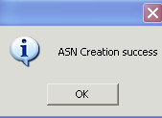

  - Completed Create ASN by PO.

  - Outstanding Inbound Report – IDDN = NA

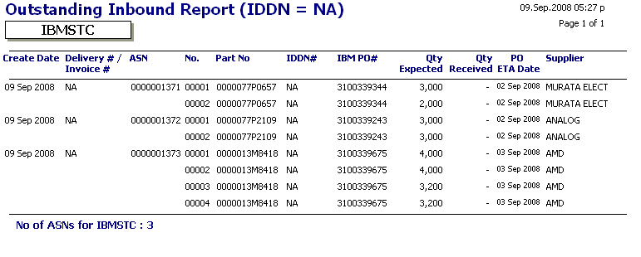

- HUB – Inbound Process
Search by PO
- Select Storer: = IBMSTC
- Enter IBM PO NO
- Click button [Search]

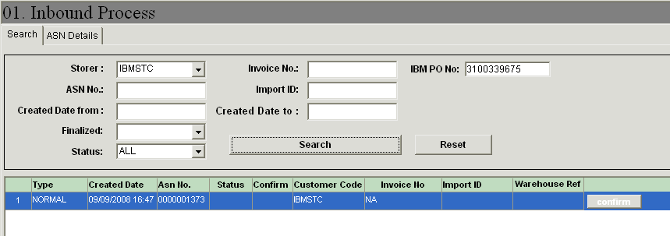
- Double click to see the ASN Details
- Enter IDDN#, HAWB, Forwarder, no of LPs, Dock Date/Time
- Enter Detail Dimension, Weight and COO
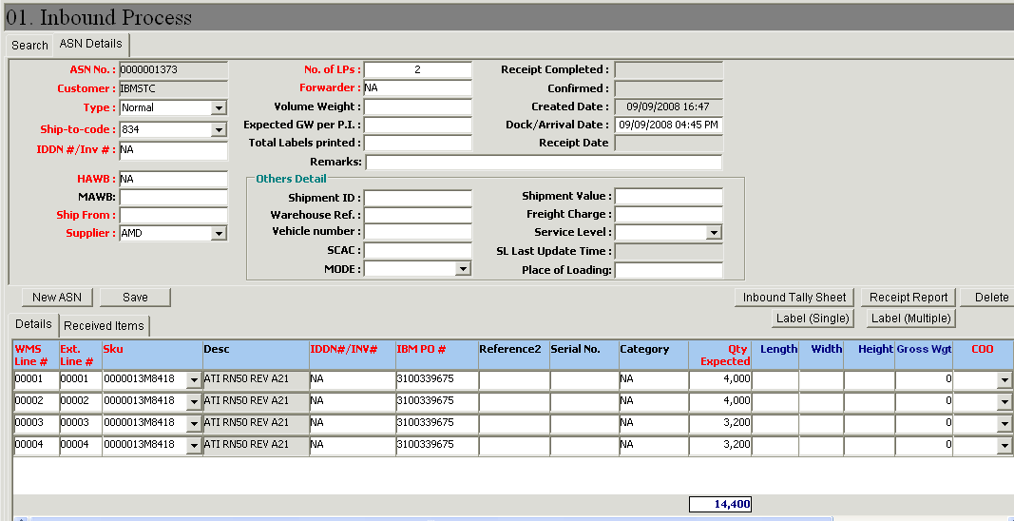
- RF Receiving (Added Loc)
Scan ASN, Line#, and LP
Enter Qty, Loc
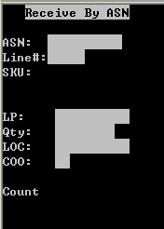

- Receipt Report
- added receiving detail : LP, Loc and qty received
- Alert message if Pending put-away.

